Register Other Product – User Manual

If agent is already registered with one product (either LACC or CMC) and if they want to register/enroll for other product, then agent can follow below steps.

Once agent login to Agent Portal below screen will be displayed.

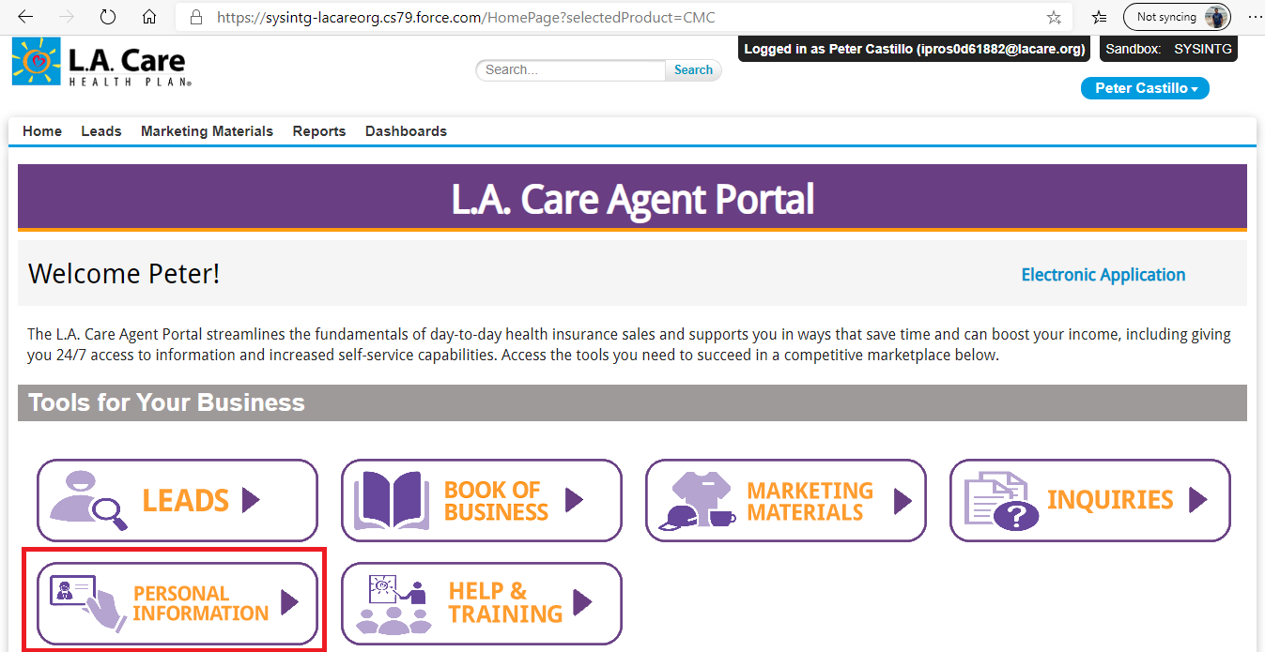

Navigate to Personal Information (above marked in Red).

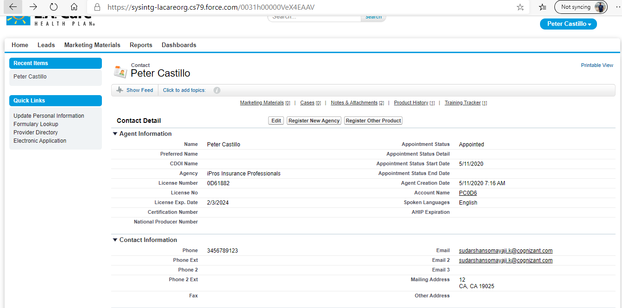

Click on Register other product button.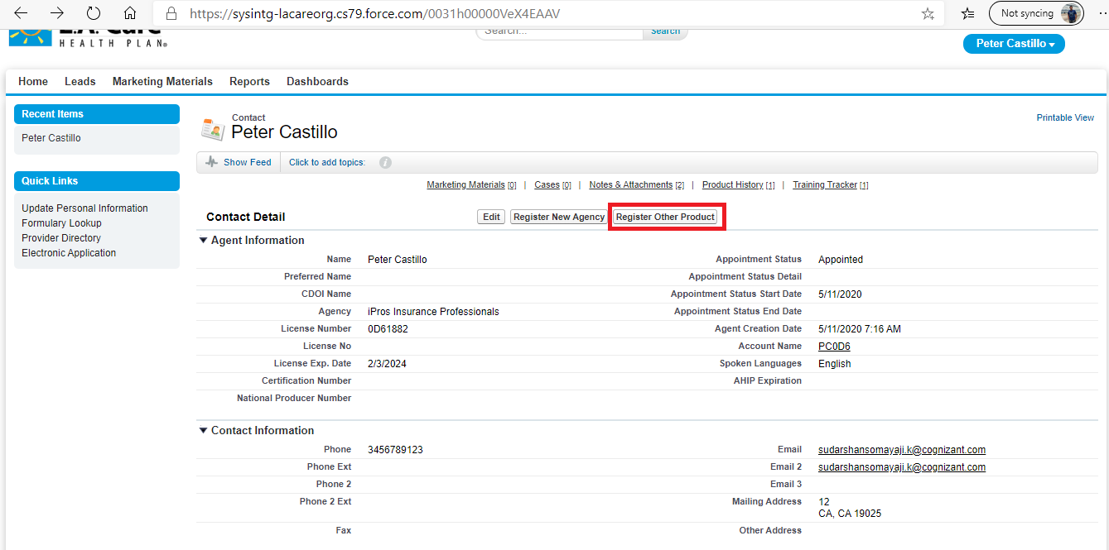

Product Selection page will be opened and select the appropriate product, to move forward.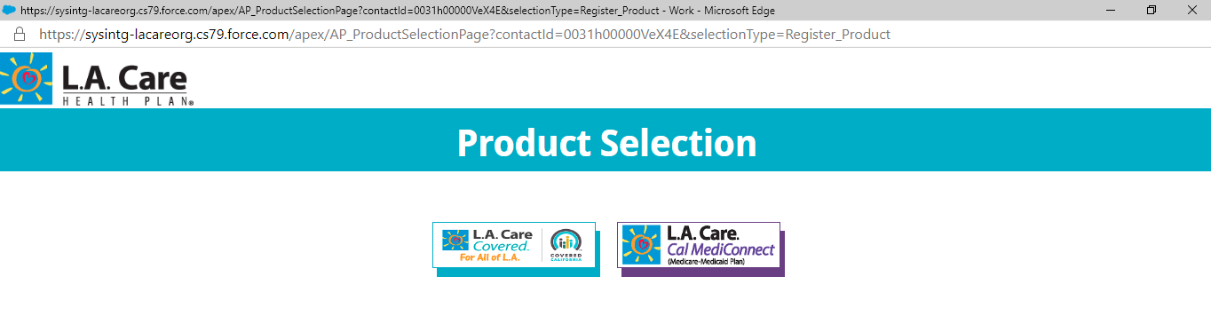

If you click on the same product which is already registered, then we will get the error message as below. Here, this agent is already registered with CMC product, so user will get error while registering for same Product.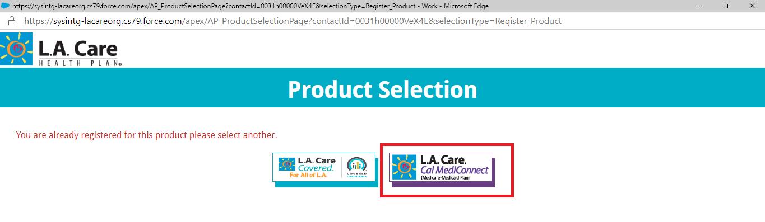

If agent click on the appropriate Product, then agent will be navigated to Prospect Agent creation page or Agent Onboarding page as below.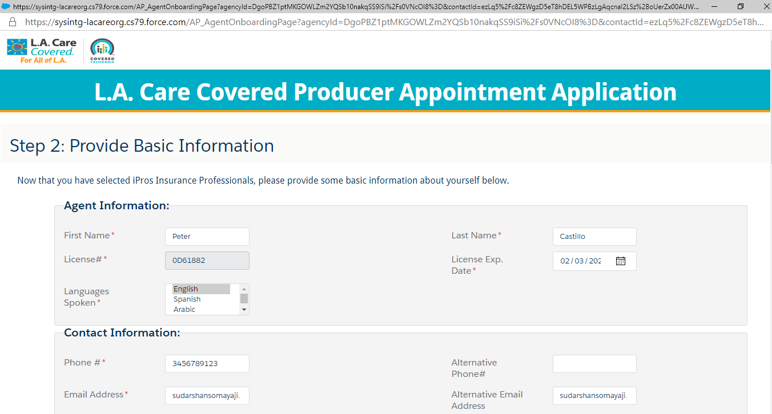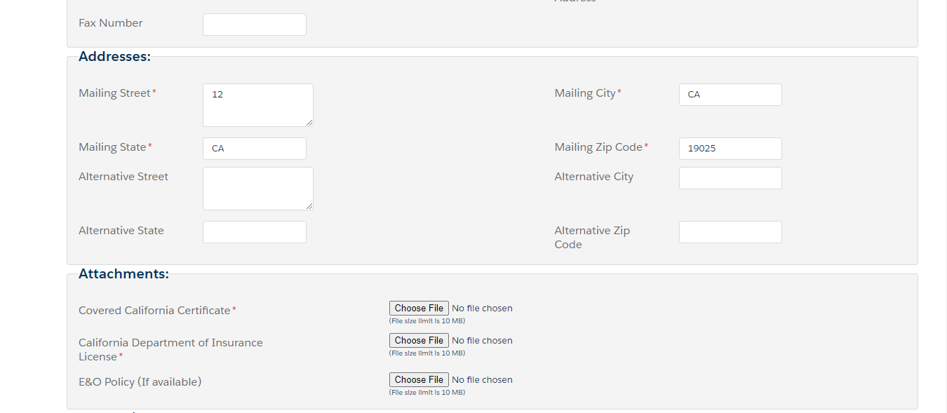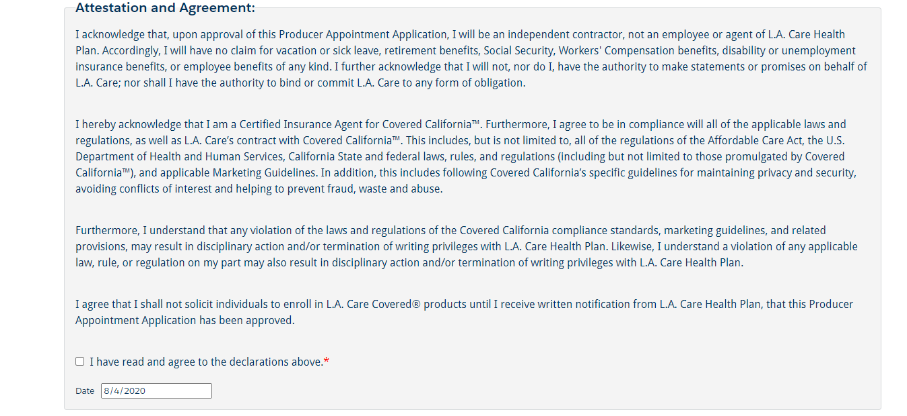

Upload required attachments and click on Submit button will navigate to Success Message page as below.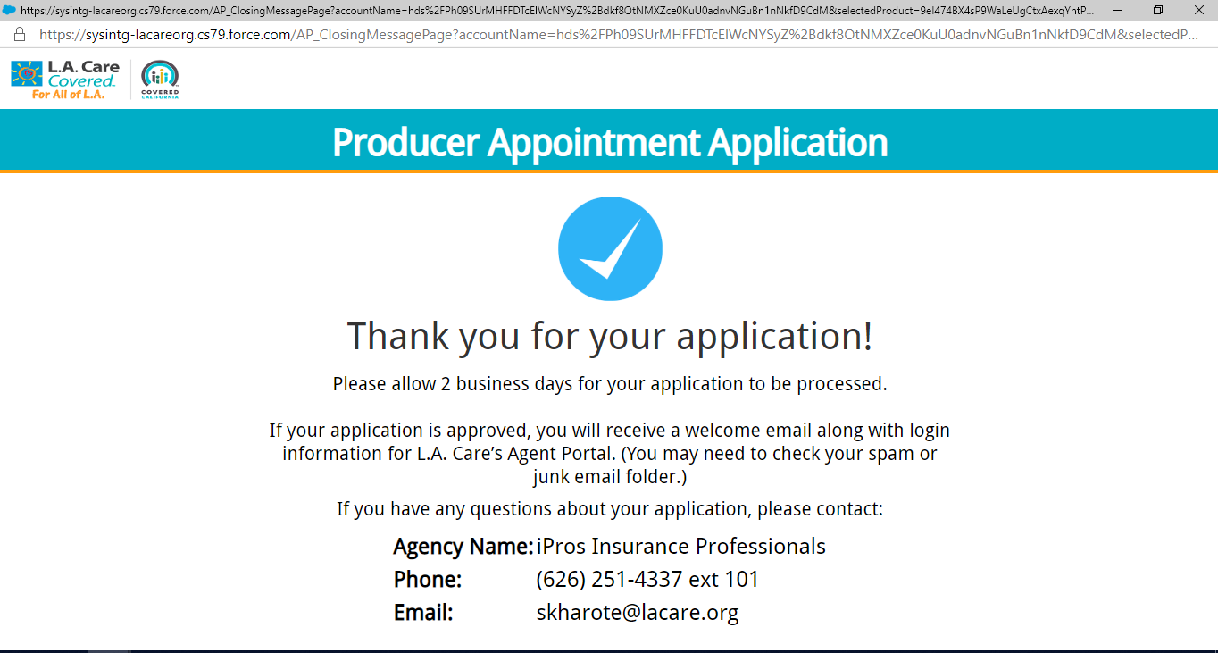

Once agent is successfully place the request, email notification will be sent to Agent and GA Admin.

Now GA Admin and S&M Admins should follow the Agent Onboarding process to enable another product for Agent.

Email to Agent:
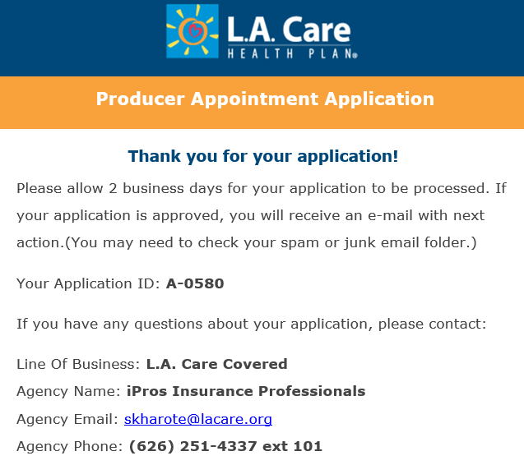

Email to GA Admin:
