BSC Medicare Product Online Certification – Broker Profile Update

General Information

Purpose | This document provides instructions on how to request a profile update to change contact information and/or agency affiliation

Audience | The target audience for this document includes:  - Brokers

Applications used | BSC Medicare Product Online Certification

Access the Request Form
After logging into the certification site, click the link on the right side of the homepage:
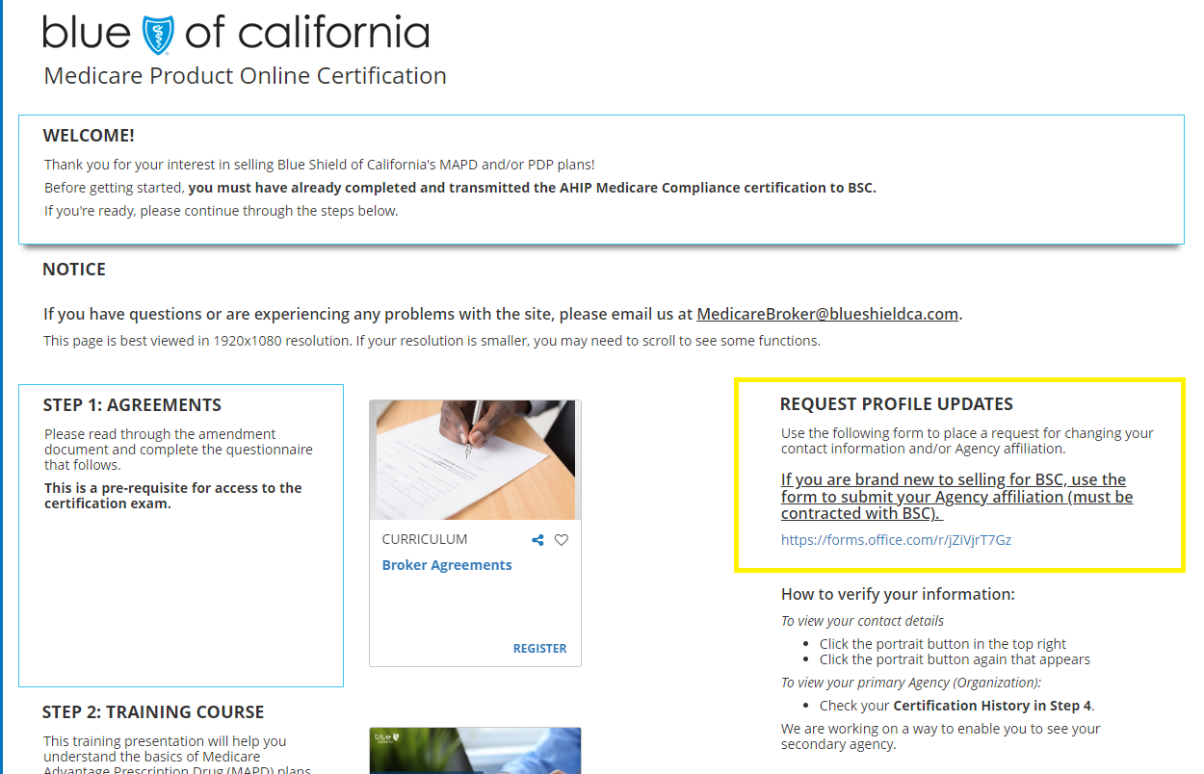

Fill Out the Request Form
Complete the required fields: Name, NPN, Email.
Complete the fields you wish to update. Leave any fields that are unchanging blank.

If you wish to update your agency affiliation, fill our question 5 and/or 8.

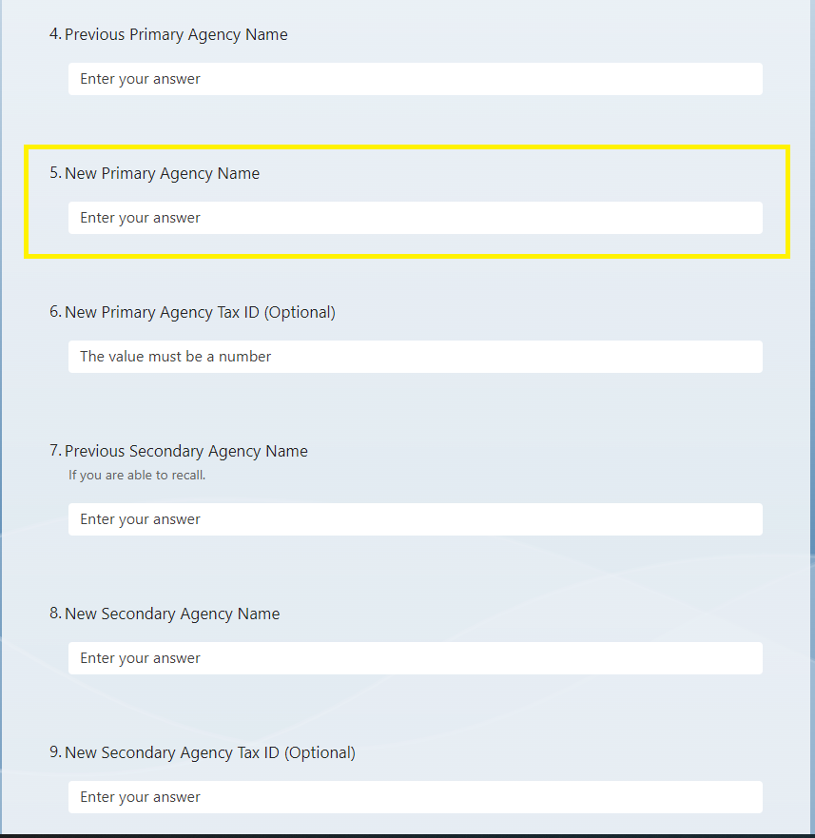

<Click> “Submit” at the bottom of the form.

