**\*\* THESE STEPS ARE ONLY FOR BROKERS WHO ARE BEING PAID DIRECTLY BY SCAN AND HAVE ALREADY BEEN PAID BY SCAN ATLEAST ONE TIME. THESE INSTRUCTIONS CAN BE USED TO SET UP DIRECT DEPOSIT FOR THE 1ST TIME, OR TO UPDATE/CHANGE ANY EXISTING BANKING INFORMATION\*\***

GO TO THIS WEBSITE AND LOG IN:

<https://www.scanproducerportal.com/>

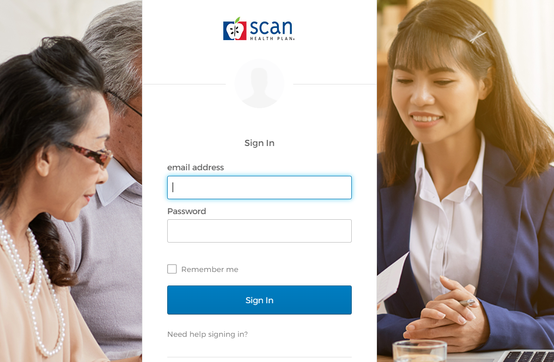

ONCE INSIDE, CLICK ON THE COMMISSIONS BOX:

THEN FOLLOW THE STEPS IN THE NEXT FEW PAGES.

Click on the **Manage** icon:

Then click on **Brokers**:

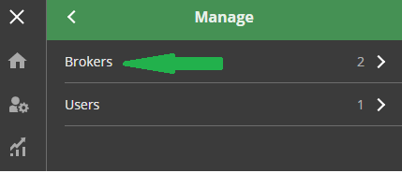

Then click on **Bank Account Maintain**:

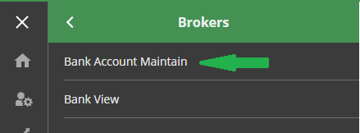

Leave all of the fields blank. Just click **SEARCH** at the bottom:

When the search results come up, click on **View** shown by the yellow box:

Only the fields in **RED** are required. Enter all banking information into these fields. Leave the rest of the fields alone. **Make sure that the Payment Type is set to ACH**. The Active field should be set to “Y.” Click **SAVE** when you are done. After you click **SAVE**, the screen will not close out on its own. It will just stay there. You can simply exit out.

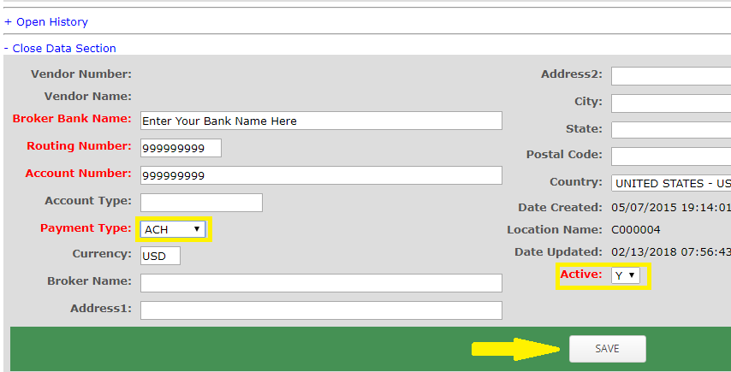

**Direct deposit will take effect after 2 payment cycles. You should still expect checks in the meantime.**