KelseyPortal

Onboarding Guide

Last modified July 15, 2024



Table of Contents

How to Access the KelseyPortal………………………………………………………………………………………. | 2
How to Setup Your Profile……………………………….………………………………………………………………. | 4
How to Upload Your Profile Documents………..………………………………………………………………… | 6
How to Take the Certification Test…………………………………………………………………………………… | 9
What to Do if Your Document is Rejected...…………………………………………………………………..… | 12
Final Approval or Rejection……….…………………………………………………………………………………….. | 15
Frequently Asked Questions……………………………………………………………………………………………. | 16


How to Access the KelseyPortal
Step 1: | For NEW agents, you will be sent an invitation via email. Follow the instructions as shown below. If you are a returning agent, go straight to the website https://kelseyportal.kelseycareadvantage.com
 | 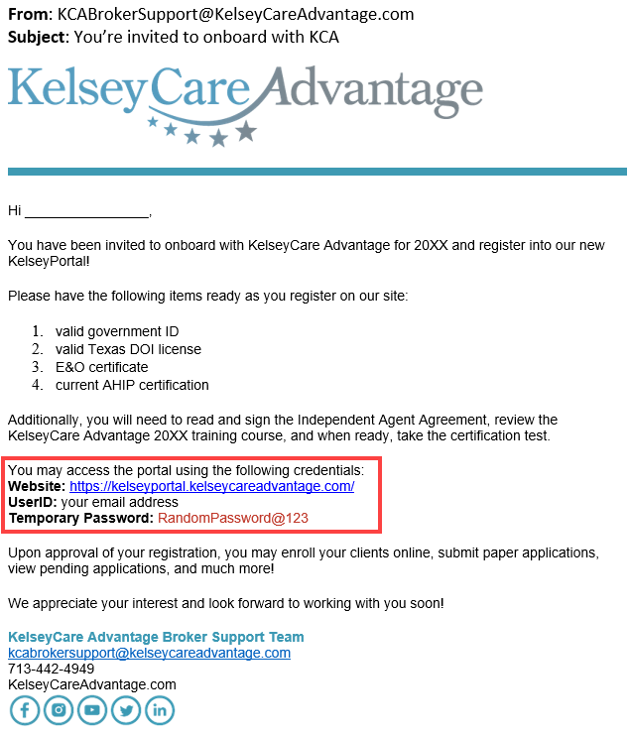
Step 2: | Click on the website link, enter your email address and temporary password
 | 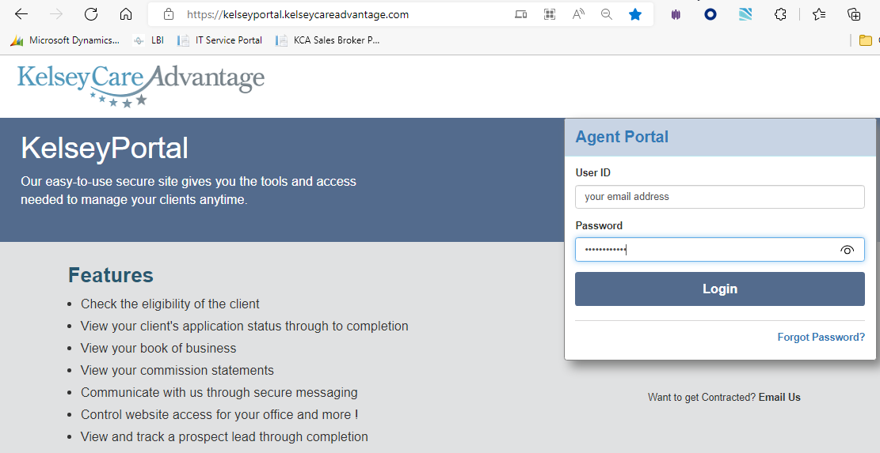
Step 3: | You will be prompted to change your password. Type the temporary password once again in the “Current Password” field, enter your new password in the “New Password” field, then once again in the “Confirm new password” field. Click the [Change Password] button to confirm
 | 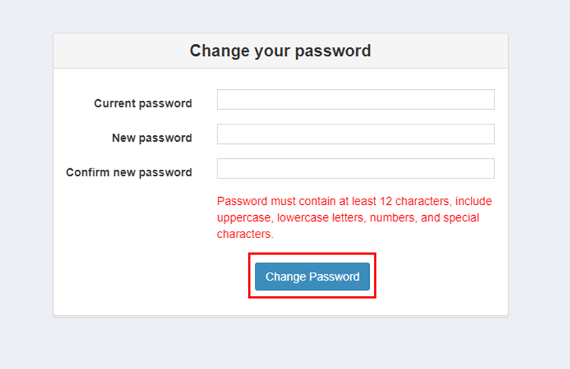
Step 4: | Once your new password has been accepted, you will be taken back to the main log in screen. Re-enter your email address and the new password you just created
 | 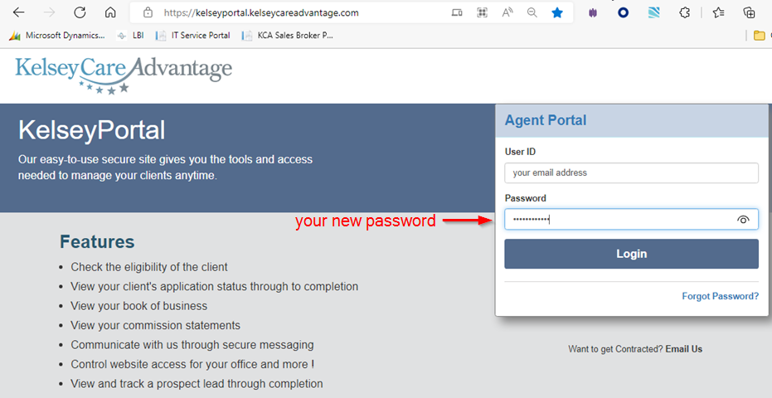
Step 5: | You may be asked for additional verification. Click the [Submit] button to receive a text message (or email) with a code. Once you receive the text, type in your 6 digit code & click the [Submit] button. If you do not receive your code, contact KCABrokerSupport@kelseycareadvantage.com
 | 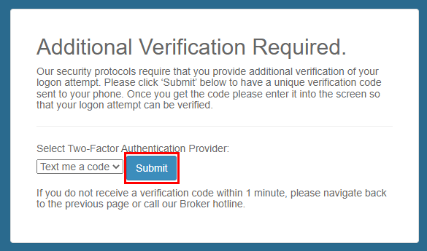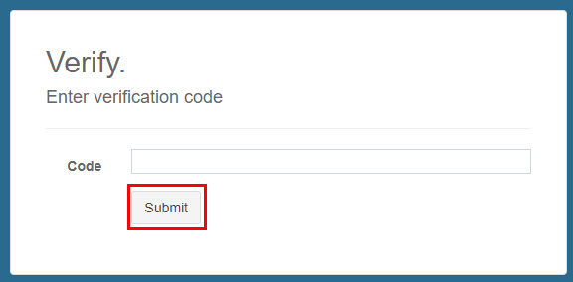

 How to Setup Your Profile
Step 1a: | Upon logging in, you will see a welcome screen. Click on the [Continue to Certification] button to move to the next step
 | 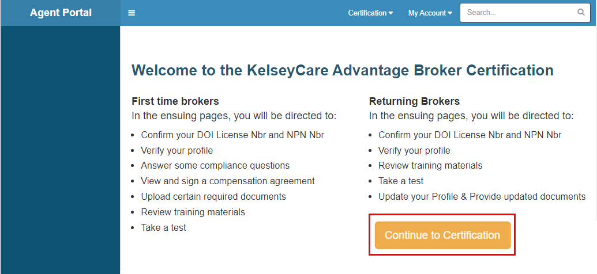
Step 1b: | If you do not land on the certification screen upon logging in, simply click on the drop-down box on the top right and select Certification
 | 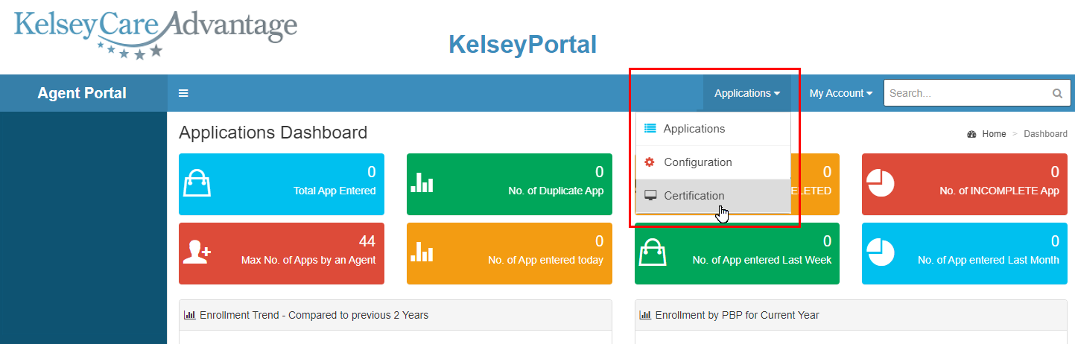
Step 2: | Confirm that the License Number & NPN # is correct, then click the [Next] button
 | 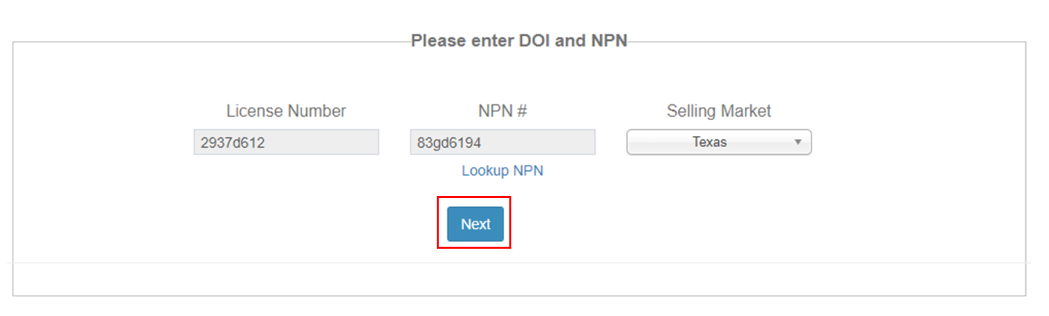

Step 3: | Fill in any missing information in the red boxes and make corrections as needed. If any of the grey boxes are incorrect, please contact Broker Support. You do not have to fill in the TAX ID if you don’t have one. Disregard the checkbox for Independent Agent. Click the [Next] button to move to the next step
 | 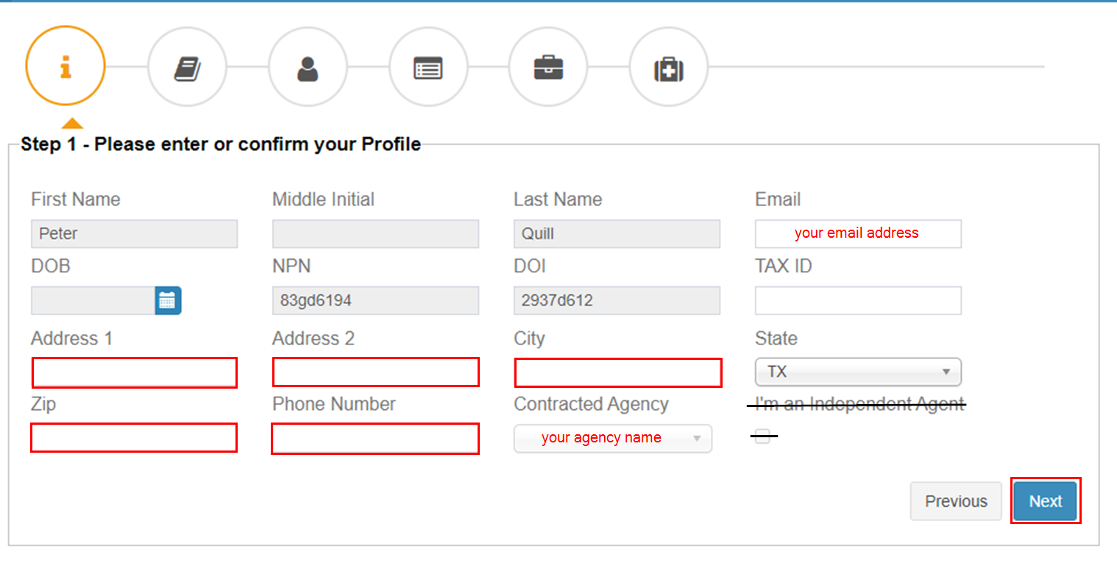

How to Upload Your Profile Documents
Step 1: | You will be instructed to upload one of each: AHIP, E&O, DOI and Government ID  - Select the document type  - Set the expiration date  - Click on [Choose a File] to find & select the document on your computer, click [Open]  - Click the [Upload] button to add your selected document to the screen below
 | 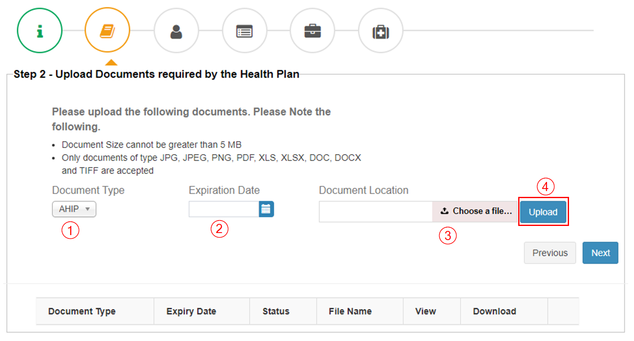
Step 2: | Repeat steps 1 through 4 until you have 4 uploaded documents showing. You will need to do this each year upon re-certification.  ***The Expiration Date on your AHIP should be left blank***  Click on the [Next] button to move to the next step.
 | 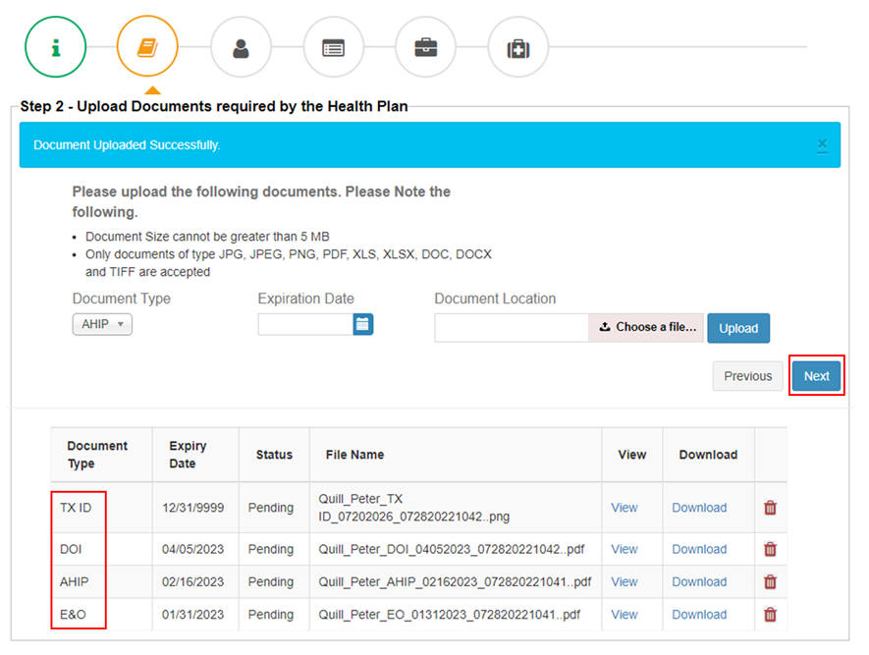
Step 3: | Confirm the information displayed is correct, then click [Next].
 | 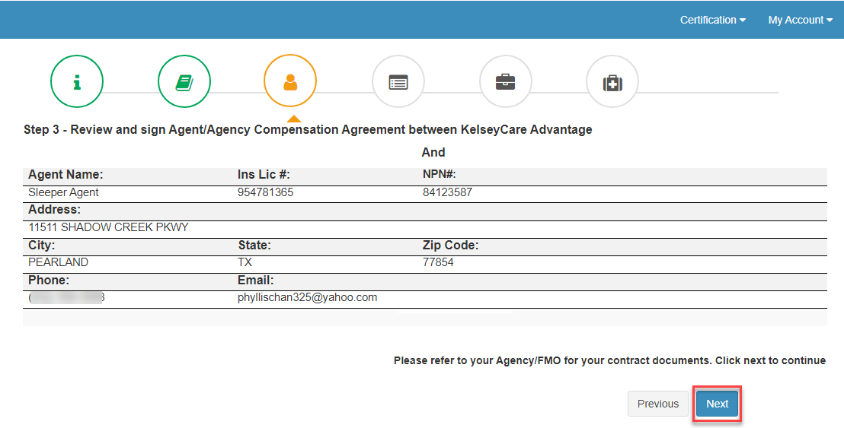


How to Take the Certification Test
Step 1: | Select the correct Year, Test Type is “Annual” and Plan is “All Benefits of KelseyCare Advantage”. Click on the [View Training Content] button to open a window to review the training.
 | 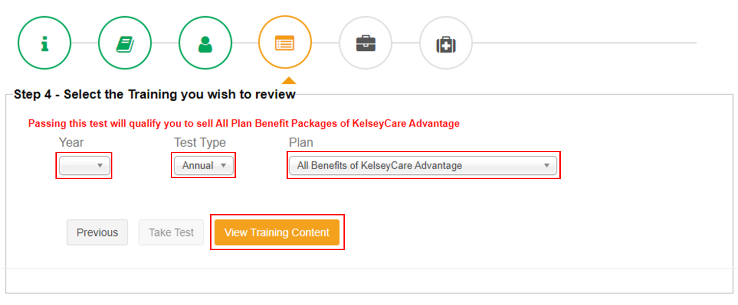
Step 2: | Take your time studying the training slides. Use the buttons at the bottom to move forward or backward. You may also click on the [Menu] button for additional notes. When you are finished, click the “x” in the top right corner of the box to close this window
 | 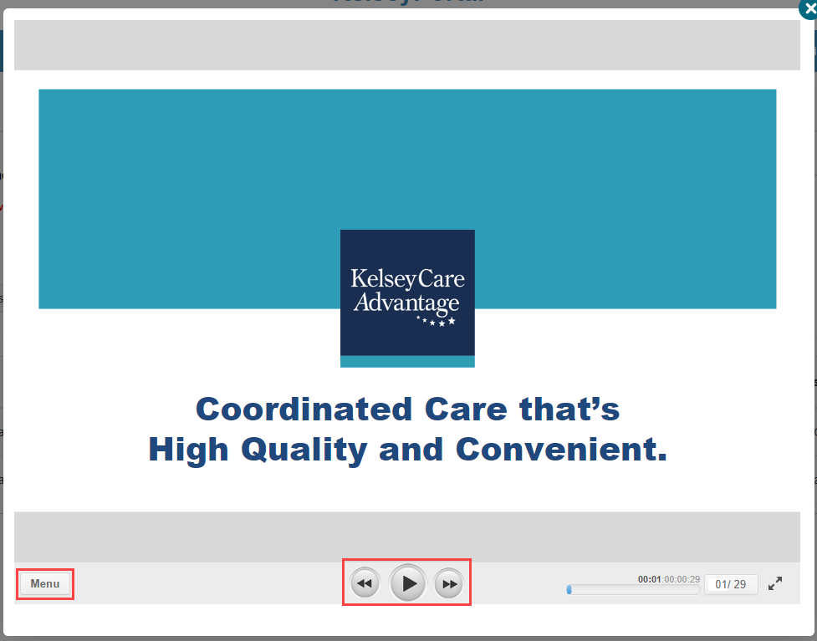

Step 3: | Click the [Download Training Material] button to save a copy of the PDF and when ready, click the  [Start Test] button to begin. Another pop-up window will appear for you to take your test
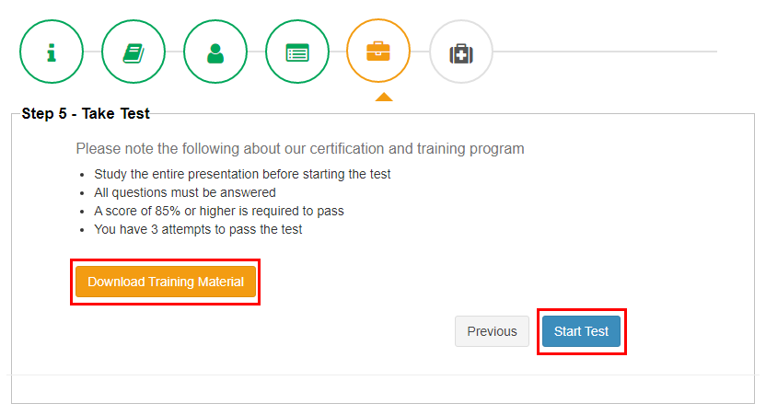
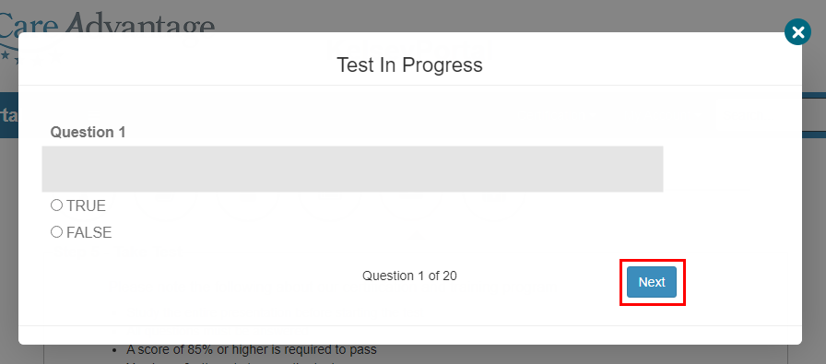

Step 4a: | If you fail, you will see the message below:
 | 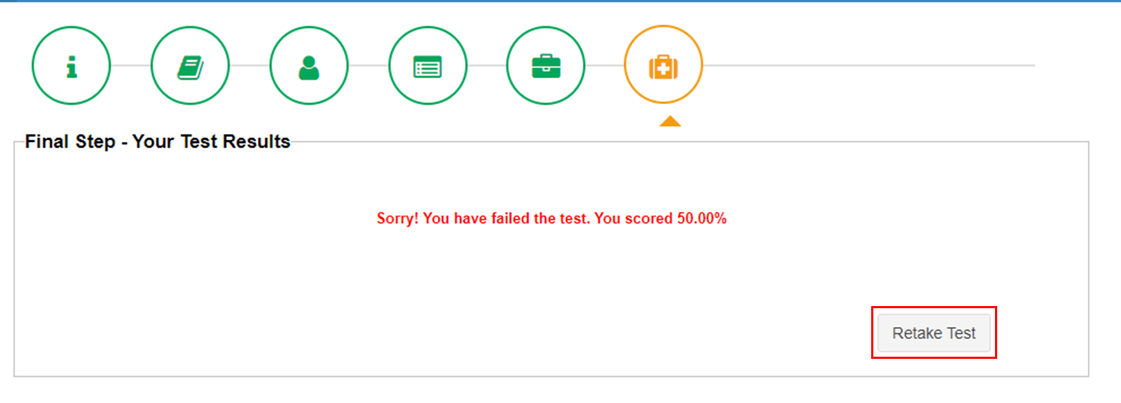

Step 4b: | When you pass the test, you will see the success message below. To finish, you can simply close the browser window, or go to the top right corner of the screen, click on “My Account” and then [Logout]
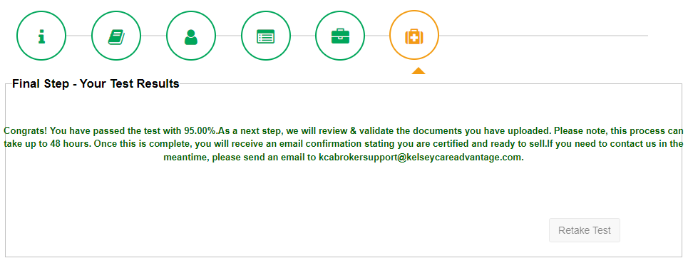

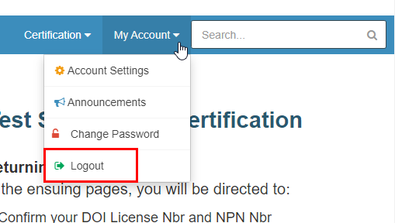

Step 5: | You will receive a confirmation email upon passing the test as well
 | 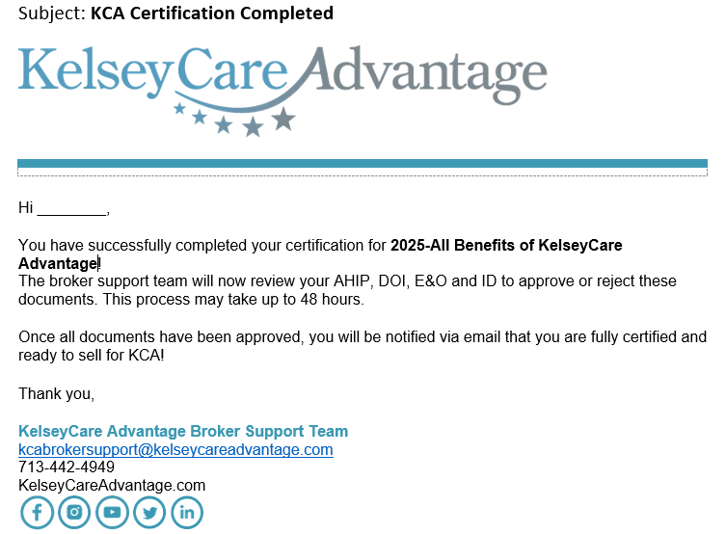


What to Do if Your Document is Rejected
Step 1: | If any of your documents (AHIP, DOI, E&O or ID) are not accepted, you will receive an email stating which document was rejected. You will need to re-upload the corrected document through the KelseyPortal
 | 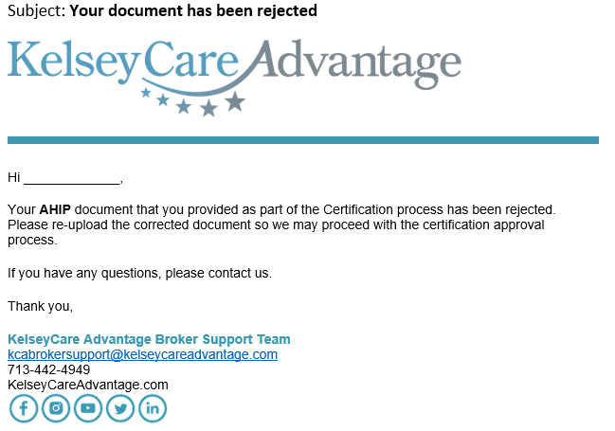
Step 2: | Login once again to https://kelseyportal.kelseycareadvantage.com and enter your username & password. Again, you may be prompted for additional verification
 | 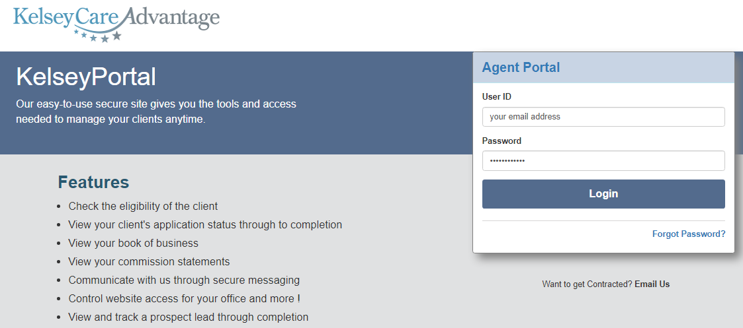
Step 3: | It will look like you need to take the certification test again, but you don’t. Click on [Continue to Certification] to get to the next screen
Step 4: | Again, bypass these 2 screens by clicking the [Next] button
 | 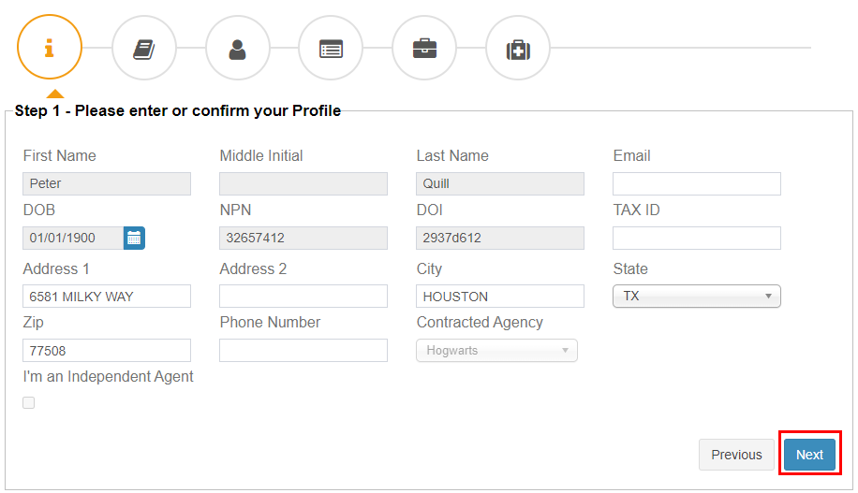

Step 5: | Once you make your way back to the Upload Documents screen, upload the corrected document following the same steps as before:  - Select the document type that was rejected  - Set the expiration date  - Click on [Choose a File] to find & select the document on your computer, click [Open]  - Click the [Upload] button to add your selected document to the screen below  - Click the [Next] button to save and you may now exit the KelseyPortal
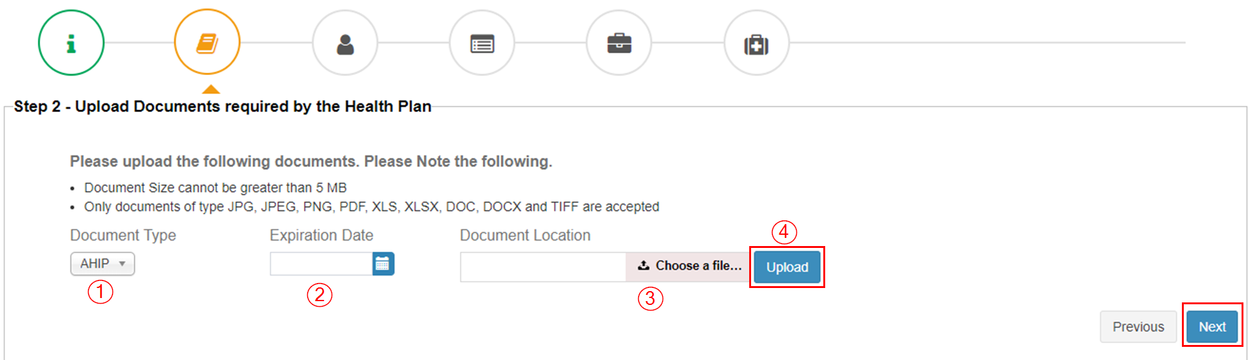
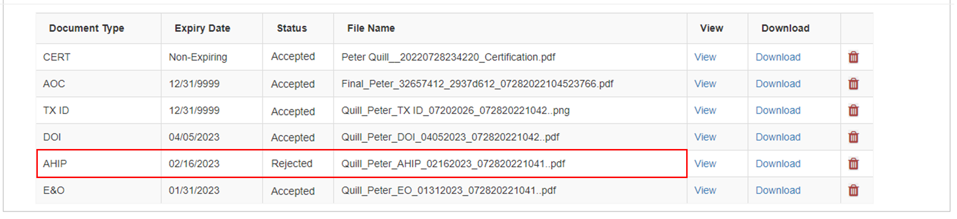


Final Approval or Rejection
Step 1: | When the KCA Broker Support team has reviewed your documents and test score, you will receive an email notification for your approval to sell for KCA!
 | 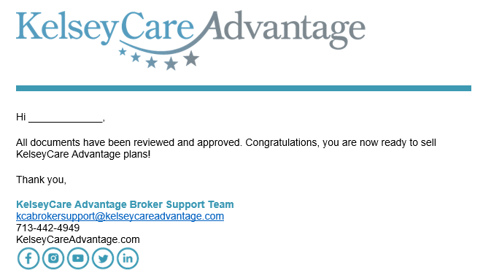
Step 2: | If the KCA Broker Support team rejects your onboarding application, you will receive a different email notification.
 | 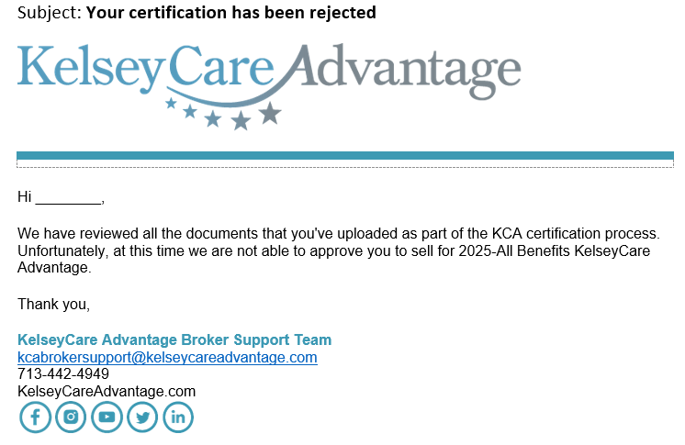


Frequently Asked Questions

Q: I didn’t get the email invitation to onboard, what do I do?
A: Please check your spam/junk email folder. You may also search for “You’re invited to onboard with KCA”. If you are still unable to locate the email invitation, contact kcabrokersupport@kelseycareadvantage.com for a password reset

Q: I don’t know what my AHIP expiration date is, what date do I use?
A: Leave the field blank, it will auto populate.

Q: What if I fail the certification test more than 3 times?
A: Send an email to kcabrokersupport@kelseycareadvantage.com to request another attempt

Q: How do I download the training materials?
A: You must first click the [View Training Content] button which prompts a pop-up window to view the training materials in a slideshow format. Once you close that pop-up window, you will have another button that says [Download Training Material] where you may download the pdf

Q: How long does it take to get approved after I’ve passed the test?
A: Typically, it will take 2-3 business days for the Broker Support Team to review/verify your documents. As we are mass onboarding agents to the new KelseyPortal, it may be a little longer

Q: Where can I view my Book of Business?
A: Once you have onboarded, you will see in your Applications module

Q: Why do I keep getting logged out?
A: The KelseyPortal is a secure site and has a timer set to log out inactive users.

Q: I received the approval email, what’s next?
A: Your assigned Kelsey Broker Sales Manager will reach out via email with future trainings and additional materials such as:
- Kelsey Portal Applications Guide
- Election Periods Guide
- Phone Enrollment Guide
- Scope of Appt Printable Form
- Applications Printable Form

