- Login to your EvolveNXT portal.
- Account View:
  - New to VNS Health: Your account will appear as shown below.
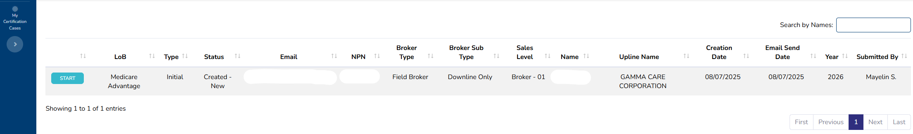

  - Recertification: If you are completing a recertification, navigate to the "My Certifications" tab, then "My Certification Cases," and click "Start" for the 2026 recertification.
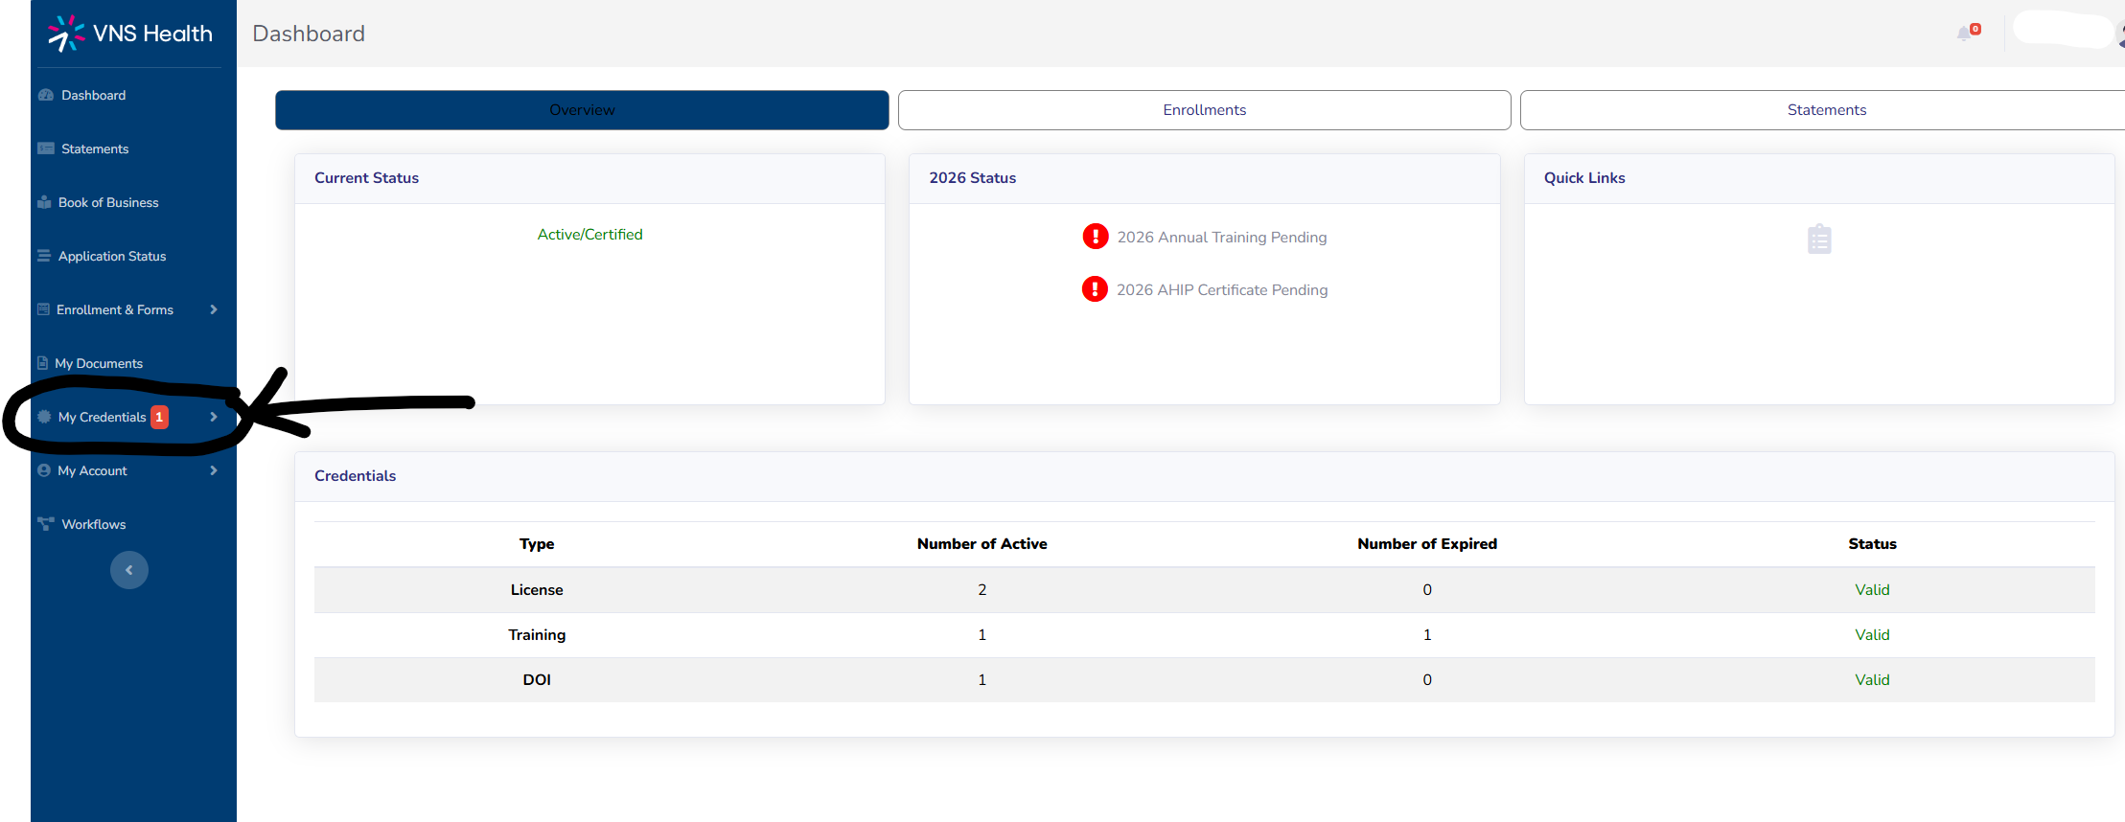

- Identity Verification: Verify your identity once during onboarding/recertification. You won’t need to verify again in the future.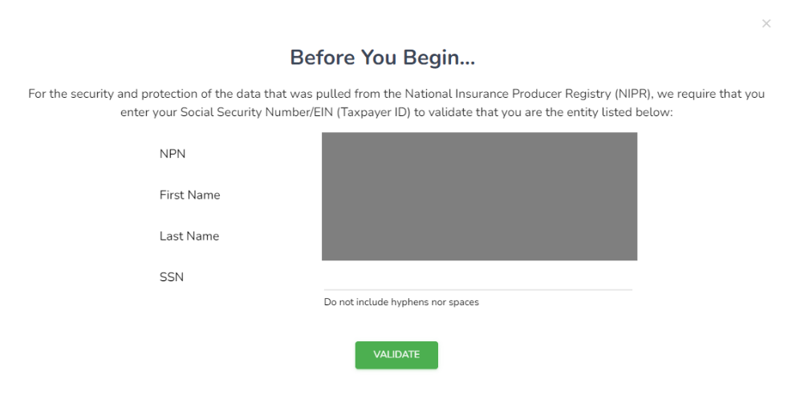
From here on, it will be smooth sailing. The VNS Health onboarding/recertification is very quick and easy to complete. You are just required to complete these sections before signing your W9 at the end. Let’s begin!

- Contact info. – Fill out as instructed.

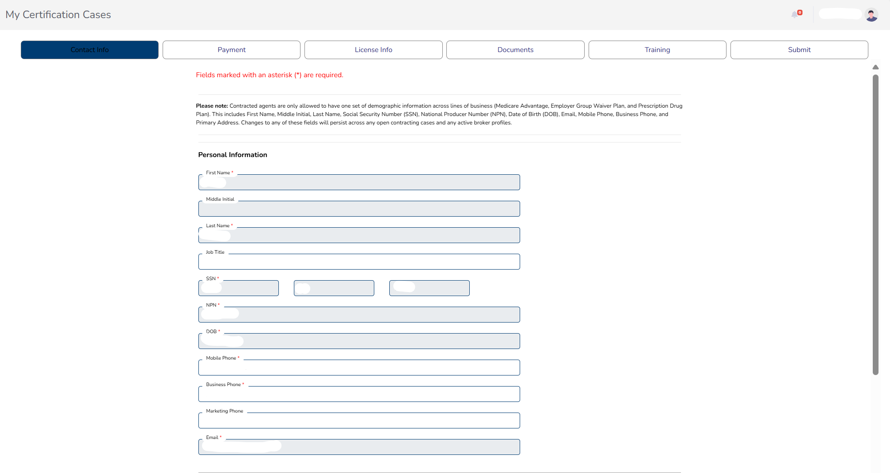
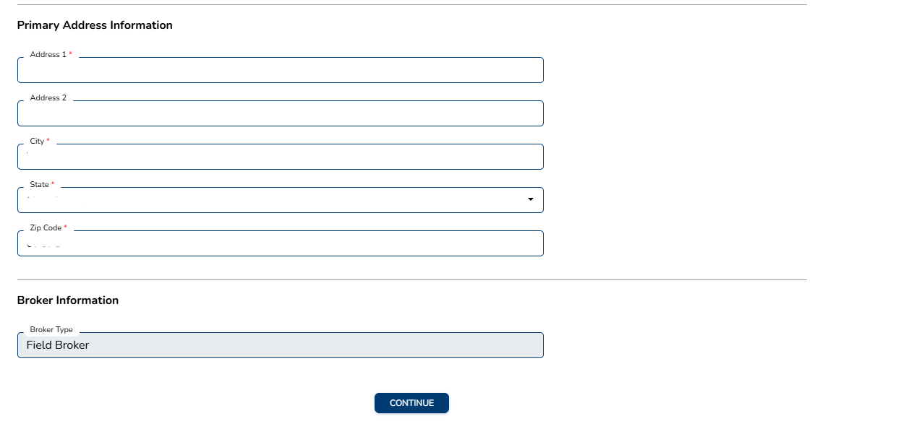

- Payment Info. – complete as indicated.

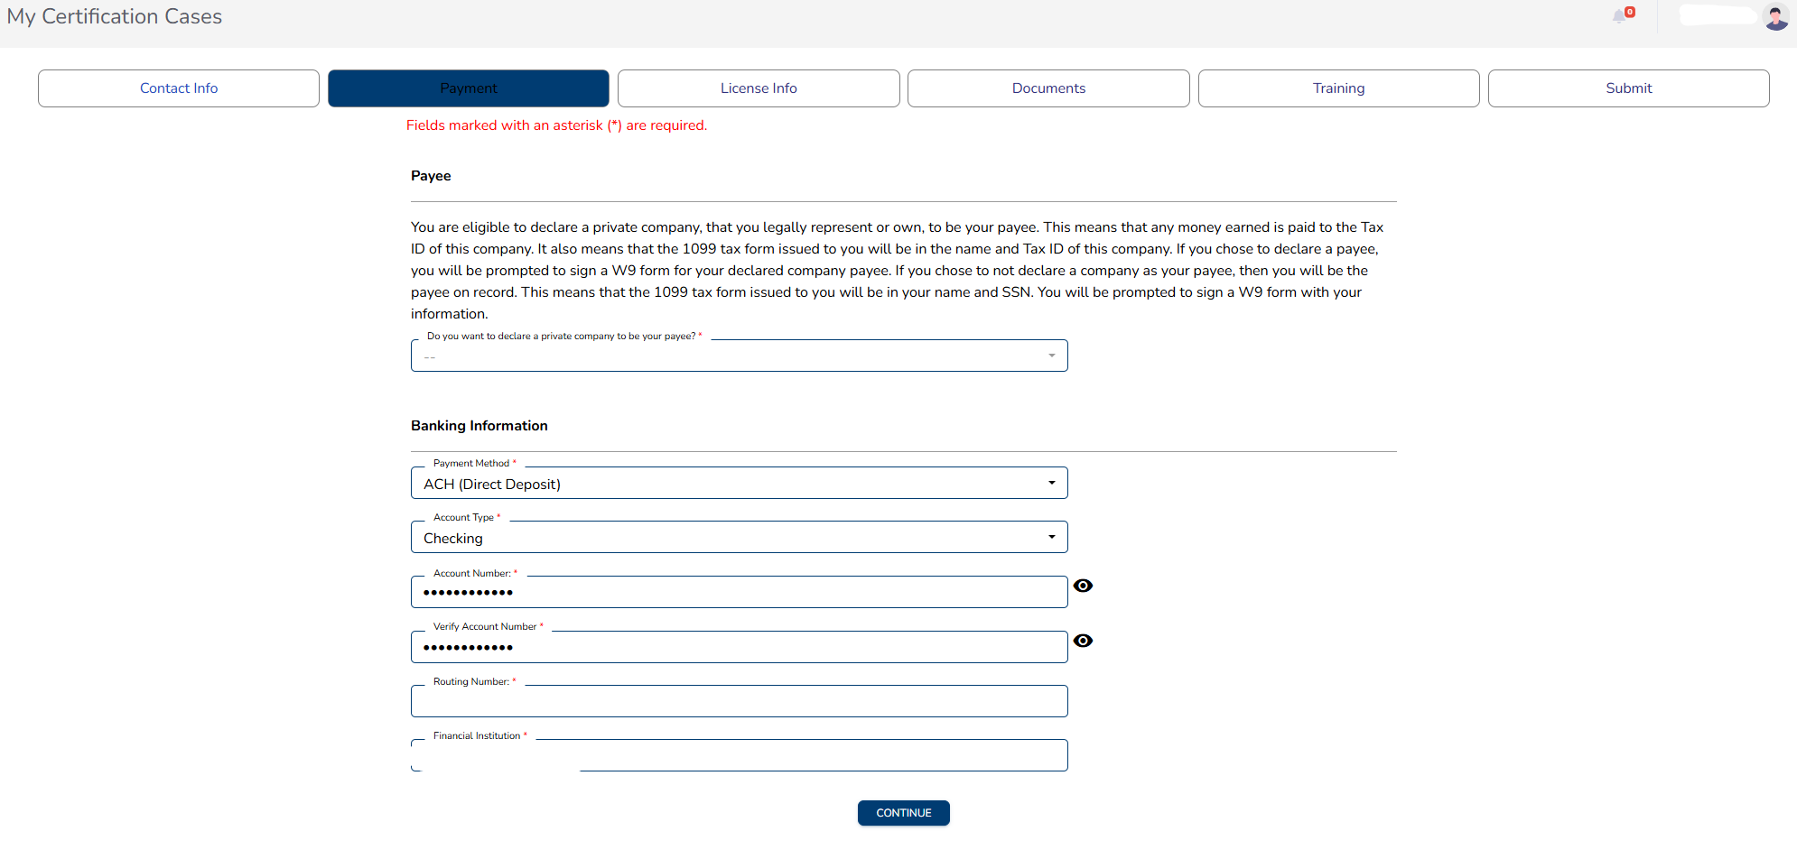

- License Info. – no action required.

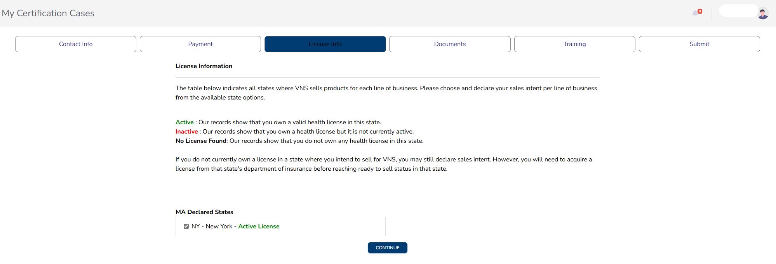

- Documents – Upload all required documents. Ensure they are up-to-date. Boxes will appear as green once uploaded.

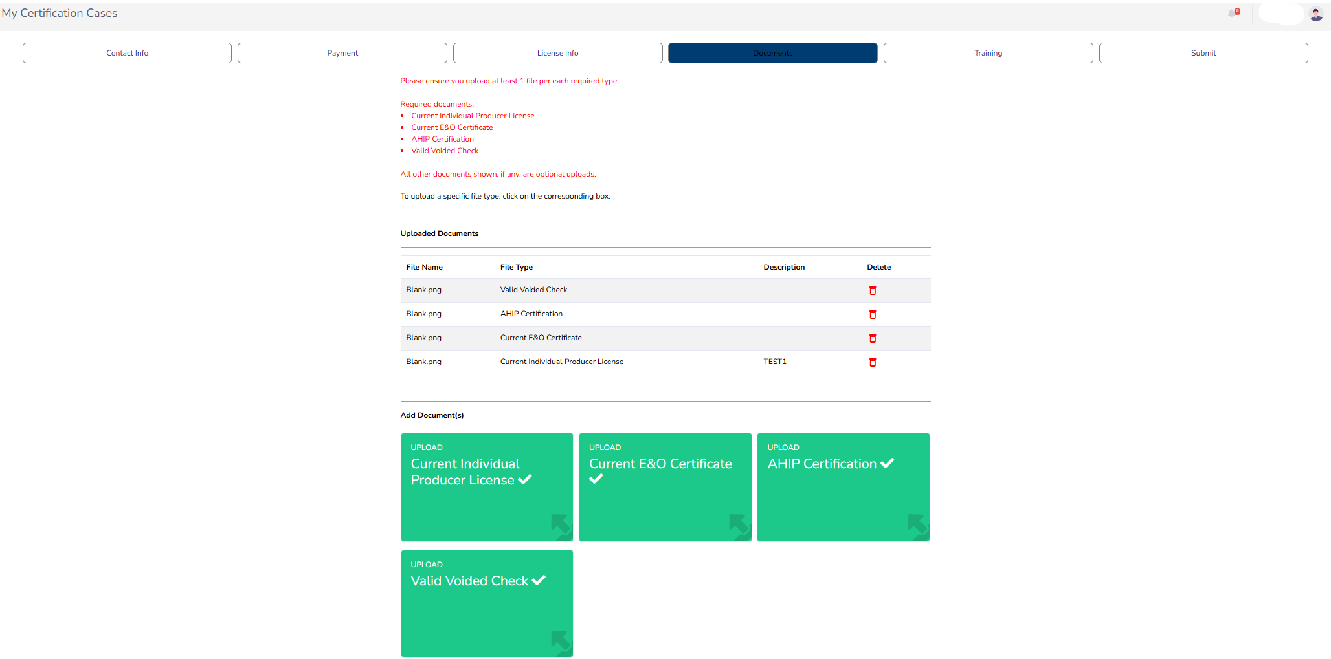

- Training – Review the training materials, then take the quiz. A minimum score of 16/18 is required.

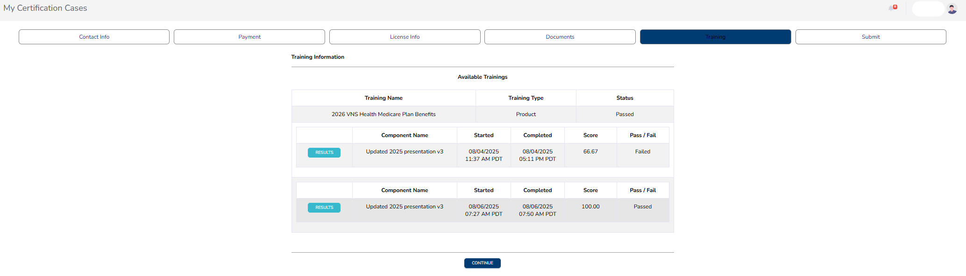

- Submit – Sign your W9, confirm you’ve reviewed it, and submit.

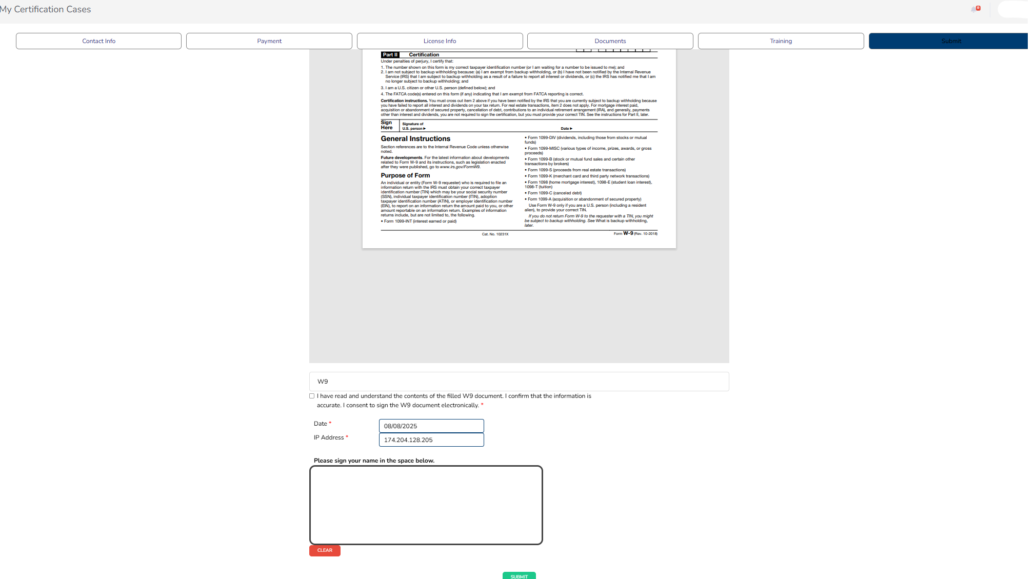

Once these steps are completed, you’re all set! The process is quick and straightforward.

