To get started, log in to the KCA Broker Portal at KCA Broker Portal. Once logged in, navigate to:
My Credentials → My Certification Cases → Start. Then follow the on-screen prompts to complete your certification requirements.
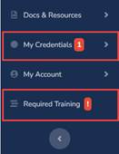
We encourage you to complete your certification as soon as possible to ensure you are ready for the 2027 Annual Enrollment Period (AEP).

